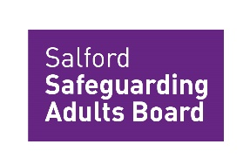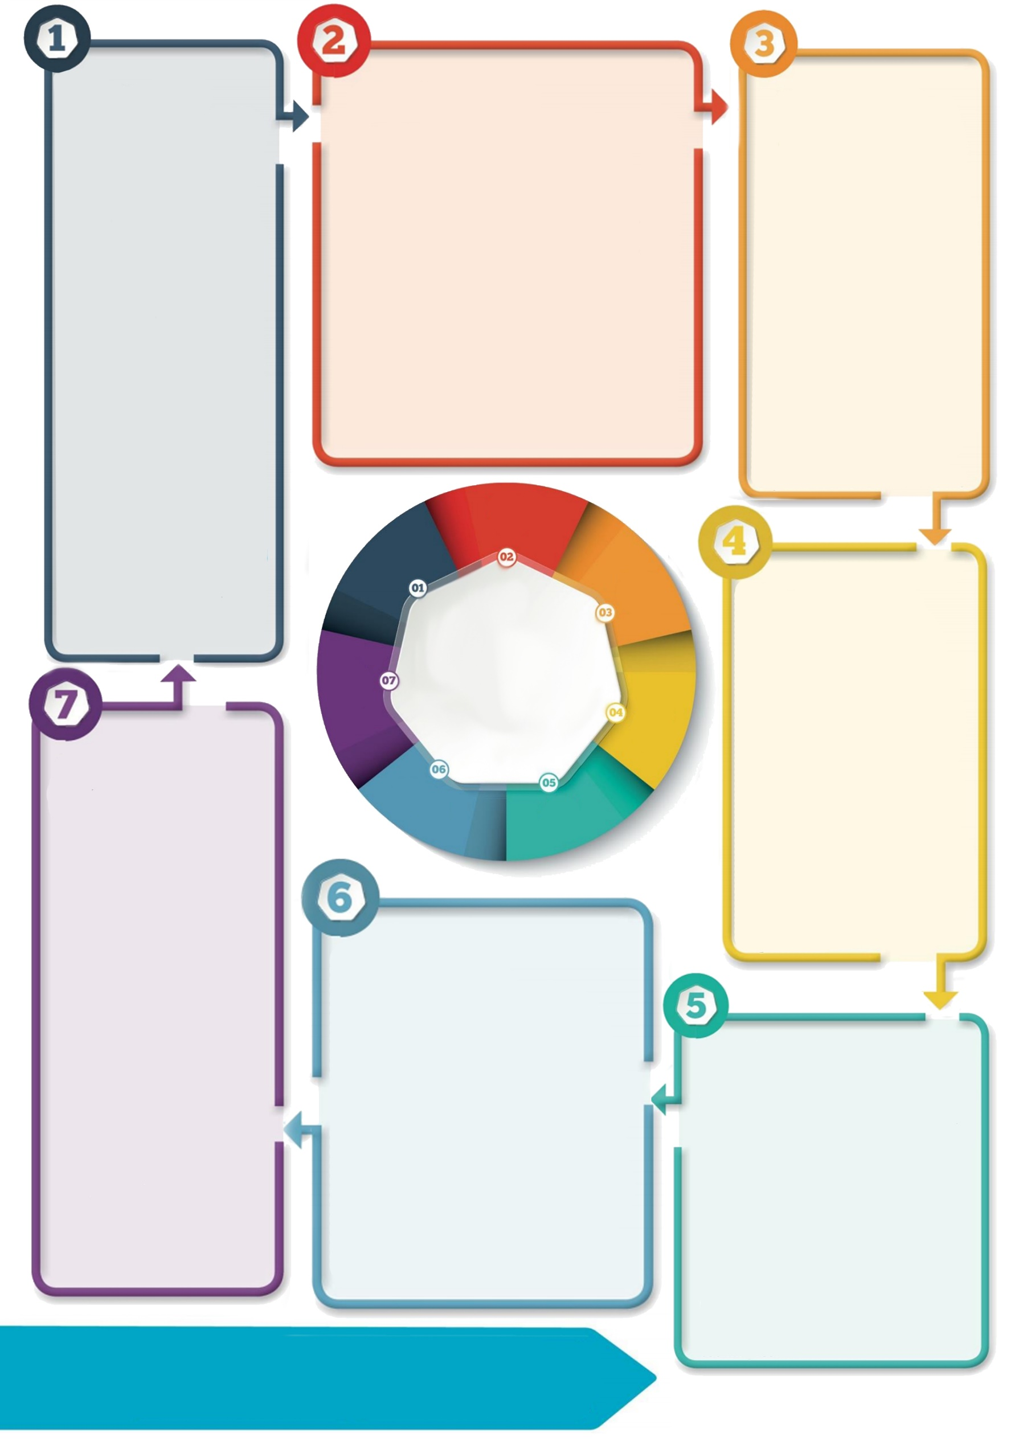

**For more information please see:**

[Care Act 2014 Legislation](https://www.legislation.gov.uk/ukpga/2014/23/section/44/enacted)

[Care and Support Statutory Guidance](https://www.gov.uk/government/publications/care-act-statutory-guidance/care-and-support-statutory-guidance#safeguarding-1) (see section 14.162-14.179)

[Safeguarding Adult Reviews (SAR) Policy and Procedure (trixonline.co.uk)](https://salfordadultsg.trixonline.co.uk/chapter/safeguarding-adult-reviews-sar?search=safeguarding%20adult%20reviews)

[Contacts and Practice Resources – Salford Safeguarding Adults Reviews](https://salfordadultsg.trixonline.co.uk/resources/contacts-and-practice-resources?root=25139bdc-6818-4b99-8ff9-d3e95dcac926)

[[SSAB Published SARs](https://safeguardingadults.salford.gov.uk/safeguarding-adult-board/safeguarding-adult-reviews-sar/published-sars-and-other-reviews/sar-mathew-2021/)](https://safeguardingadults.salford.gov.uk/safeguarding-adult-board/safeguarding-adult-reviews-sar/published-sars-and-other-reviews/)

Please contact the SSAB Team if you have any questions or need any further information: [ssab@salford.gov.uk](mailto:ssab@salford.gov.uk)

0161 212 6176

**Making a referral**

If you feel a case meets the criteria or would benefit from a review, you may need to discuss it with your manager depending on your role.

The case can be referred to the SAR Panel for consideration which meets monthly.

See the SAR Referral form found on this page.

**Contact details:** [**ssab@salford.gov.uk**](mailto:ssab@salford.gov.uk)

[**Worried about an adult?**](https://adultsportal.salford.gov.uk/web/portal/pages/home) **Call 0161 206 0604**

[**https://safeguardingadults.salford.gov.uk/**](https://safeguardingadults.salford.gov.uk/)

**Purpose of the SAR**

Agencies who were involved with the adult are required to co-operate and contribute to the carrying out of a review with the **aim not to re-investigate or apportion blame but to identify any lessons to be learnt to improve practice** from the adult’s circumstances and **applying those lessons to future cases.**

**The SAR Process**

The SAR Panel will consider whether the case meets the criteria for a mandatory or discretionary SAR. **If you are invited to a SAR panel or learning event, please remember it’s a supportive and reflective process not a scrutiny on practice.**

An independent chair / author may be commissioned to lead the review or provide other support. A Review Panel will be established to review what happened and lessons can be learned.

Once the review is complete, the learning identified will be shared and the report may be published.

**What happens next?**

The SSAB Team will screen the referral and ensure it is appropriate. If it is, it will be placed on the agenda for the next SAR Panel meeting.

The SSAB Team will contact partner agencies to establish who else may have been in contact with the adult and ask them to provide a reflective summary of their involvement.

The SSAB Team can offer support with summaries if needed.

**Introduction**

**Section 44 (1) of the Care Act 2014** places a statutory duty on Safeguarding Adults Boards (SAB) to conduct Safeguarding Adult Reviews in certain situations. They must conduct **mandatory reviews** for adults with care and support needs where there is **reasonable cause for concern about how professionals worked together to safeguard the adult**; **and** certain conditions are met.

**Conditions for a SAR**

**Condition 1 is met if:**

1. The adult had died, and
2. The SAB knows or suspects that the death resulted from abuse or neglect (this is regardless of whether or it was known about beforehand)

**Condition 2 is met if:**

1. adult is still alive, and
2. the SAB know or suspects that the adult has experienced serious abuse or neglect.

SABs can also arrange **discretionary** reviews in **any other case.**

**Safeguarding Adult Reviews (SAR)**

**Sub Title**